

**Simple, preventative maintenance for your new** **Bravilor 75 Cup Percolator**

To maintain the 35-minute percolation time of your Bravilor 75 Cup Percolator we advise that once a month you undertake a few simple maintenance steps. Many areas within the UK suffer from hard water, which in turn results in the build-up of scale. This can occur within the circular hole located in the internal base of the percolator and around the central stainless-steel tube. The build-up can also be a result of the natural oils in coffee. However, such issues can be countered by following some very simple preventative maintenance measures which we have described below.

**Step 1 - De-scale**

* Dissolve the contents of one Bravilor 50g Renegite Sachet (depicted below) into a jug of hot water ensuring the crystals are fully dissolved. Take the internal central stainless-steel coffee spout/rod from the percolator and leave in this solution for a few minutes; remove and clean the end of the disc with an abrasive sponge. Rinse with cold water. Empty the same solution into your percolator, ensuring that at least two inches in depth covers the internal base of your machine. Replace the lid and power up the percolator for 10-15 minutes. Turn the power off before removing the lid and using a kitchen cleaning brush, like the one pictured below. Clean out the central hole at the base of the percolator. When completed, tip the contents of the percolator into your sink and rinse with fresh cold water.

[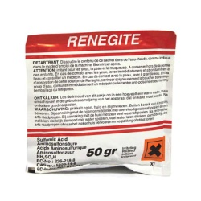](https://www.google.co.uk/url?sa=i&rct=j&q=&esrc=s&source=images&cd=&cad=rja&uact=8&ved=2ahUKEwi8-p3sn_ffAhUO1hoKHc5cAqgQjRx6BAgBEAU&url=https://www.coffeesuppliesdirect.co.uk/bravilor-bolero-xl423-kenco-millicano-branded-3d-body-kit-1148-p.asp&psig=AOvVaw3MV2sfvnLDhG7BqfIu4NOc&ust=1547898030031675) [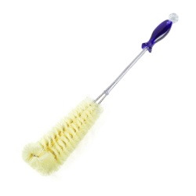](https://www.google.co.uk/url?sa=i&rct=j&q=&esrc=s&source=images&cd=&cad=rja&uact=8&ved=2ahUKEwiMyPqDoPffAhVEhxoKHWmCDYoQjRx6BAgBEAU&url=https://alexnld.com/product/long-handle-flexible-bottle-cleaning-brush-thermos-teapot-cleaner-easy-kitchen-cleaning-tools-home-cleaning-supplies/&psig=AOvVaw3BSzWA6vilCgHYli-Y0zvX&ust=1547898115688121)

**Step 2 - Cleaning**

* Sprinkle a tablespoon of Puly Caff powder into the base of your percolator and fill with water to half volume.  Fit the central spout and stainless-steel filter basket before replacing the lid.  Power up the machine and allow the percolator to run for 10-15 minutes. Turn off the power and empty the contents in the sink. Gently scrub the internal surfaces of your percolator with an abrasive kitchen sponge and then rinse out with clean water. This should remove any tannins created by the coffee oils and will return the percolator to a shiny, clean condition. Furthermore, it will help to regulate the percolation time.

[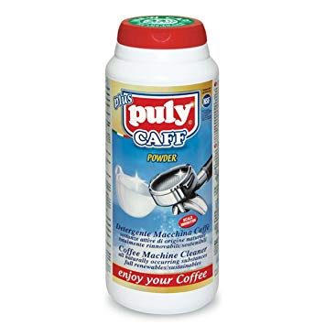](https://www.google.co.uk/url?sa=i&rct=j&q=&esrc=s&source=images&cd=&cad=rja&uact=8&ved=2ahUKEwjPw47KoPffAhVS1BoKHS24A8cQjRx6BAgBEAU&url=https://www.amazon.co.uk/Puly-Caff-Coffee-Cleaning-Powder/dp/B00VEBBQV6&psig=AOvVaw23xl3ygcerbC8SAv68M5b-&ust=1547898243759246)[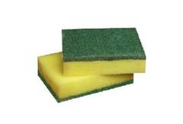](https://www.google.co.uk/url?sa=i&rct=j&q=&esrc=s&source=images&cd=&cad=rja&uact=8&ved=2ahUKEwjQjay-ipreAhVNz4UKHXjhClsQjRx6BAgBEAU&url=https://www.exportersindia.com/indian-suppliers/sponge-scouring-pad.htm&psig=AOvVaw0nLKHqKNu3yV7J7mlL4ova&ust=1540298812017333) 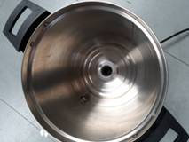

**NB:** Both the Renegite 50g De-scaler sachet and 900g tub of Puly Caff Powder are available to purchase through Kingdom Coffee

* Order code 111-031 - Bravilor Renegite De-scaler 1 x 50g - £0.89 + vat each
* Order code 222-005 - Puly Caff Group Head Cleaner 1 x 900g - £6.99 + vat

If you have any questions, please feel free to contact our office on 0118 986 8786.

